# Creating an EC2 instance

1. Sign in to the AWS Management Console: <https://141650580409.signin.aws.amazon.com/console>
2. Navigate to the EC2 console: <https://console.aws.amazon.com/ec2/> or click below:

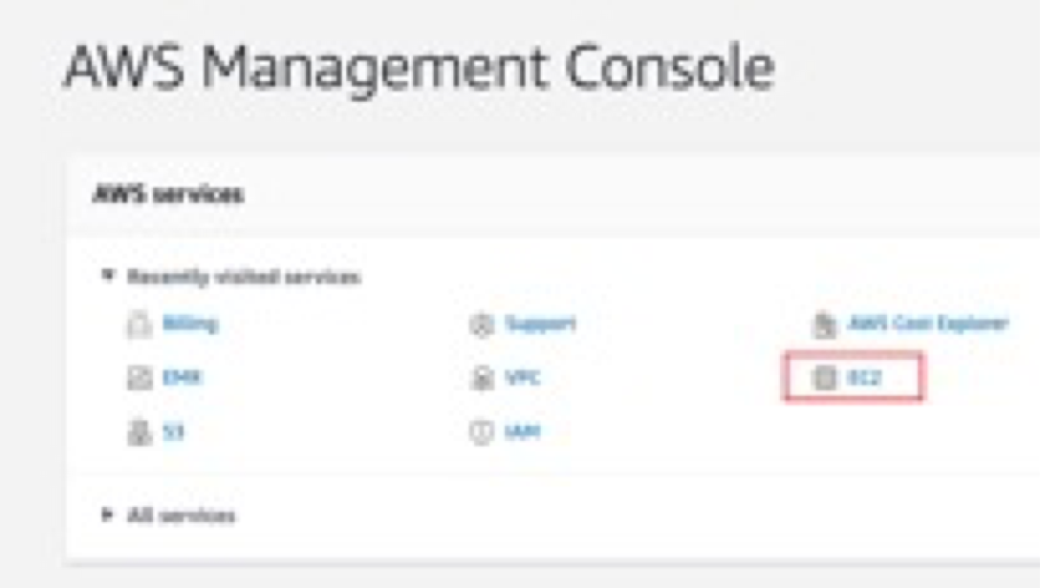

1. Choose **Launch instance**

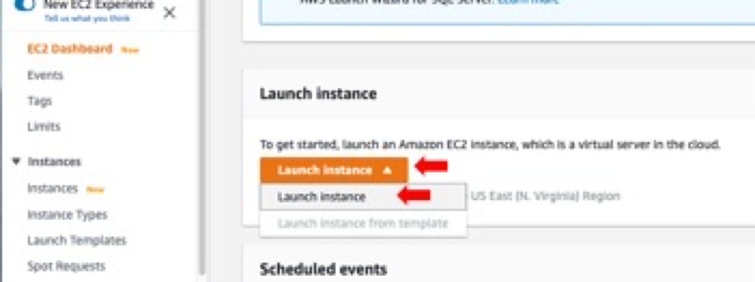

1. If you are planning to run a Docker container, it is a good idea to search for instances with Docker pre-installed. The same goes for any other software that you intend to use. Search for **Docker** in the search bar, then select any instance that you prefer:

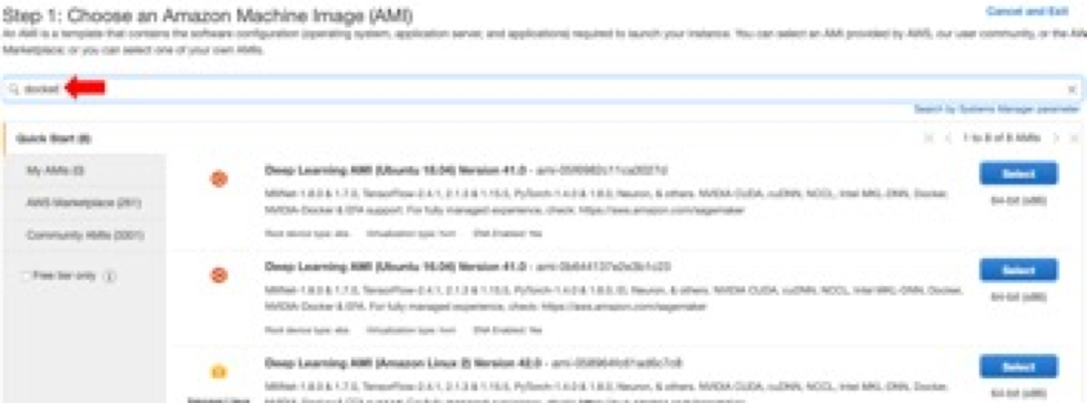

1. Choose the instance type, then click Review and Launch.

**Note:** For bioinformatics analyses (e.g. Tourmaline), t2-nano and t2-micro are way too slow and definitely not sufficient. Here is a detailed list of the CPU, memory, storage and network performance for EC2/EMR instances: <https://aws.amazon.com/ec2/instance-types/>.

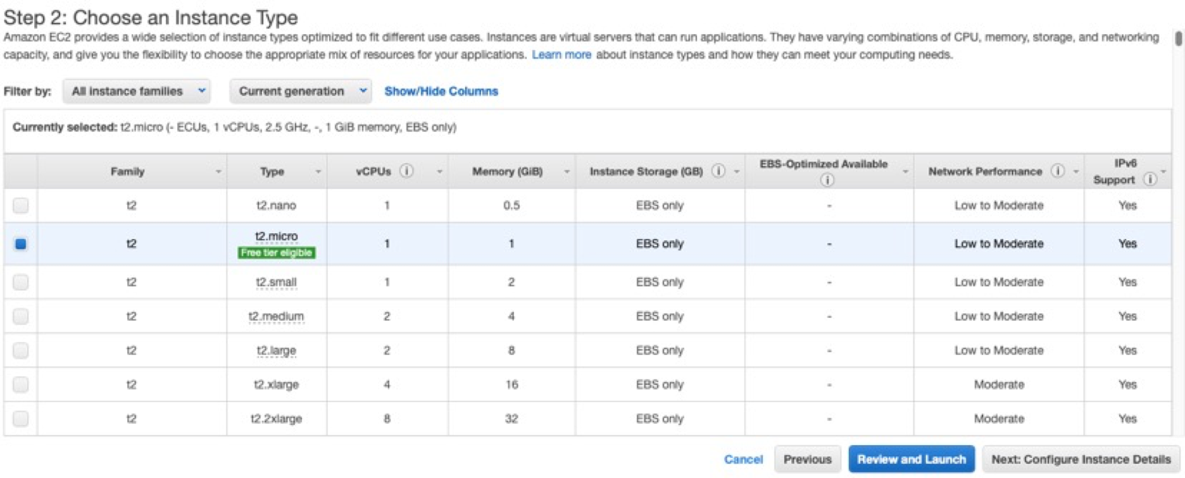

Example specifications from <https://aws.amazon.com/ec2/instance-types/>. Note that there are other types of instances besides t2 (e.g. T3, M4 etc).

|  |  |  |  |  |  |
| --- | --- | --- | --- | --- | --- |
| Instance | vCPU* | CPU Credits / hour | Mem (GiB) | Storage | Network Performance |
| t2.nano | 1 | 3 | 0.5 | EBS-Only | Low |
| t2.micro | 1 | 6 | 1 | EBS-Only | Low to Moderate |
| t2.small | 1 | 12 | 2 | EBS-Only | Low to Moderate |
| t2.medium | 2 | 24 | 4 | EBS-Only | Low to Moderate |
| t2.large | 2 | 36 | 8 | EBS-Only | Low to Moderate |
| t2.xlarge | 4 | 54 | 16 | EBS-Only | Moderate |
| t2.2xlarge | 8 | 81 | 32 | EBS-Only | Moderate |

1. In the next screen, you can configure your instance, for example, you can specify the number of cores and threads and more by checking on **Specify CPU options**

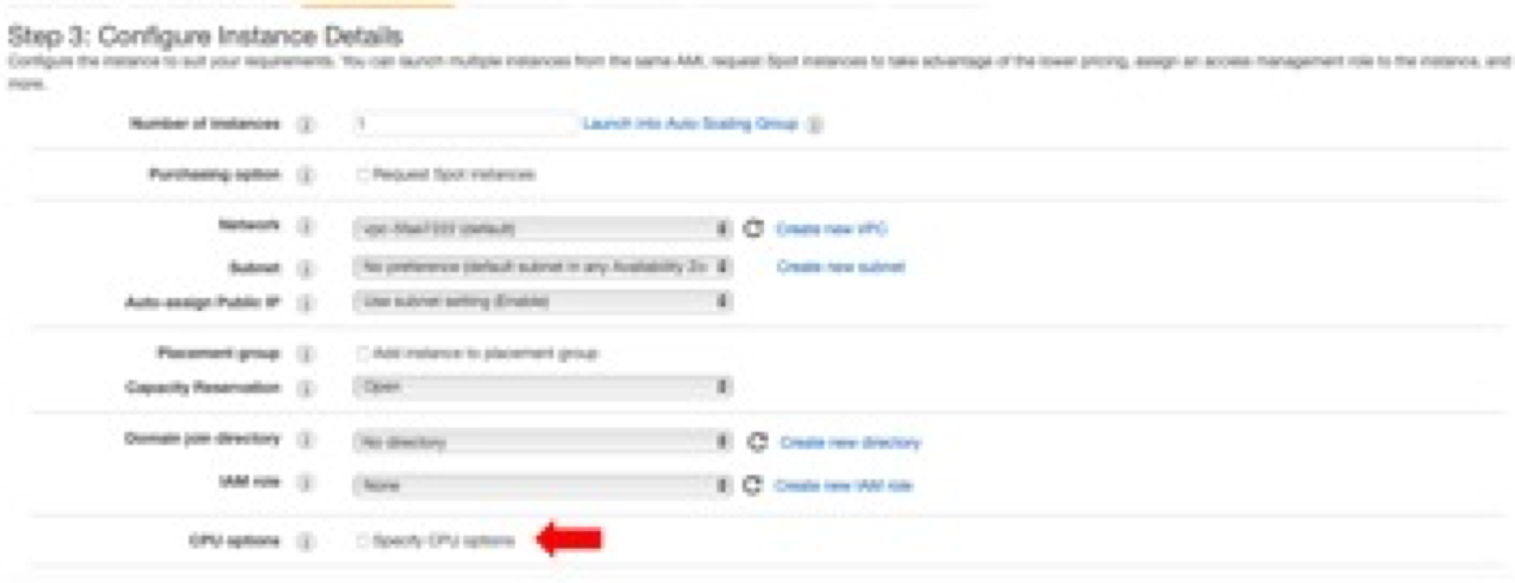

1. In the Specify CPU options window, you can click on the Information (i) button to learn more about each option.

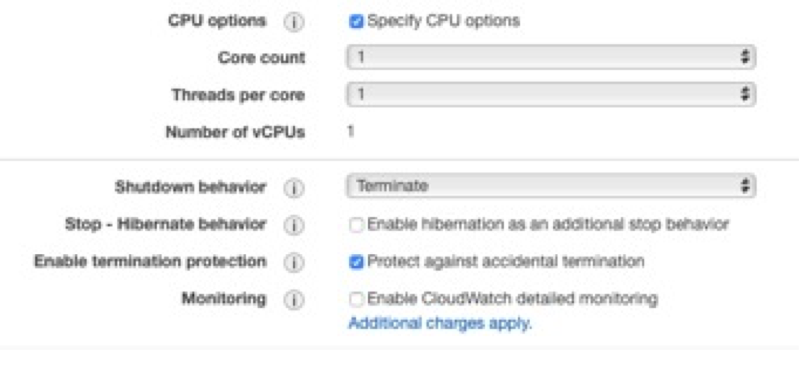

1. You can also configure the **storage device** on the instance. More information at: <https://docs.aws.amazon.com/emr/latest/ManagementGuide/emr-plan-storage.html>

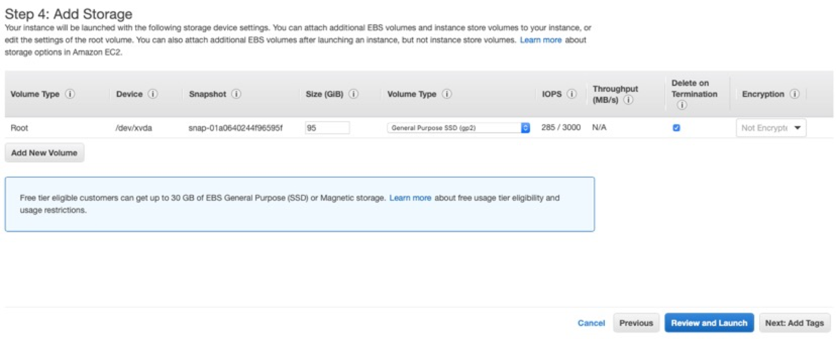

1. [Optional]: Add **Tags** to your instance.

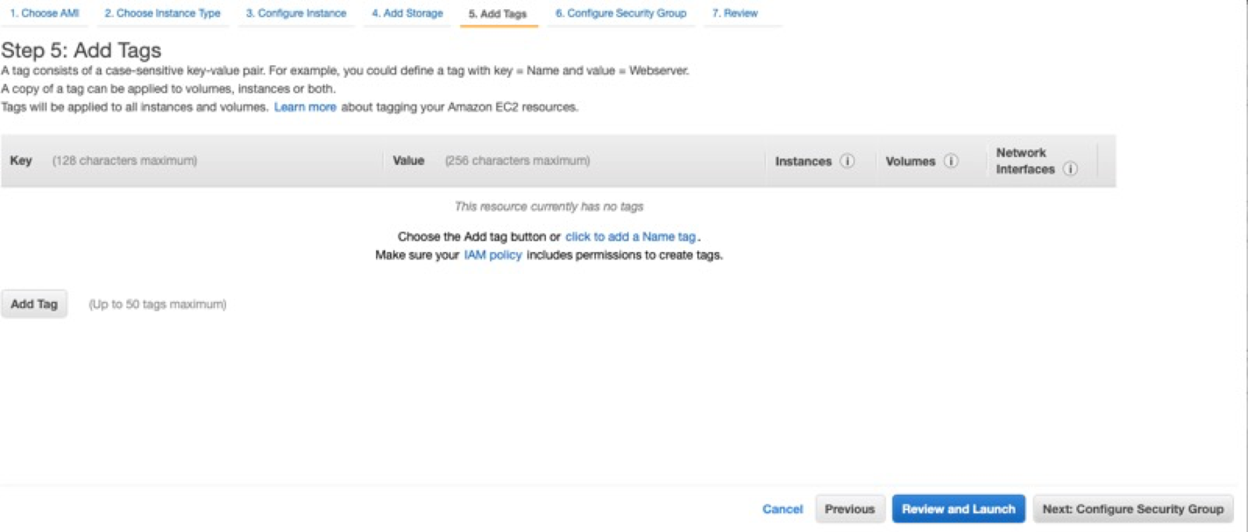

1. [Important]: **Configure security groups**. By default, the rule accepts inbound SSH connections on port 22 from all IP addresses (0.0.0.0/0). It is recommended that you change this to restrict SSH connections from your IP address only. To do that, click on the Drop down menu, then select “**My IP**”. The default address (0.0.0.0/0) should be replaced by your IP address. Click “Review and Launch” to launch your instance.

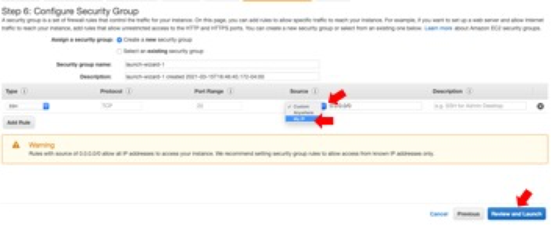

1. In the next screen, you will be prompted to select a key pair or create a new key pair if you haven’t already.

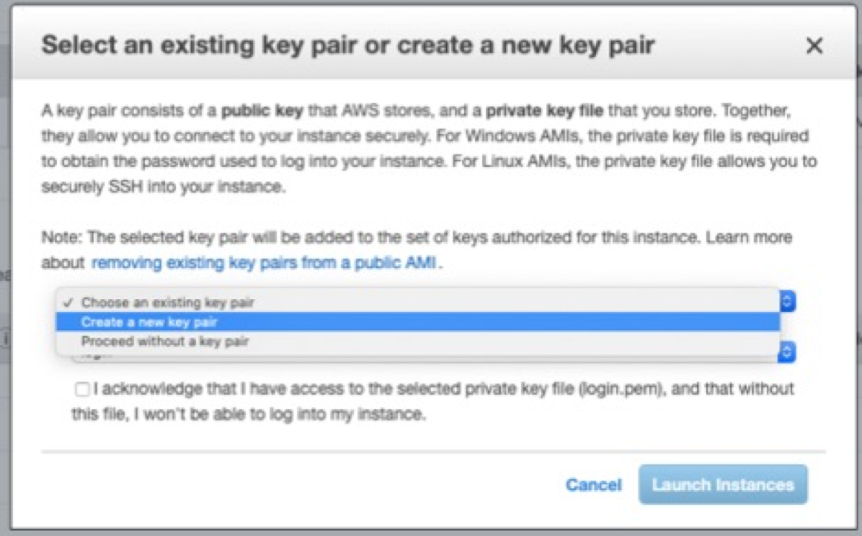

1. If creating a new key pair, you can name your key pair and download the key pair, then click “**Launch Instance**”

It looks like only **pem** key pairs (for OpenSSH in MacOS/Unix platforms) can be created and downloaded on the fly. If you are using PuTTY for Windows, Mac, or other OS, you will need the key pair in PuTTY’s proprietary **ppk** format – refer to the Appendix for creating a key pair in the EC2 console.

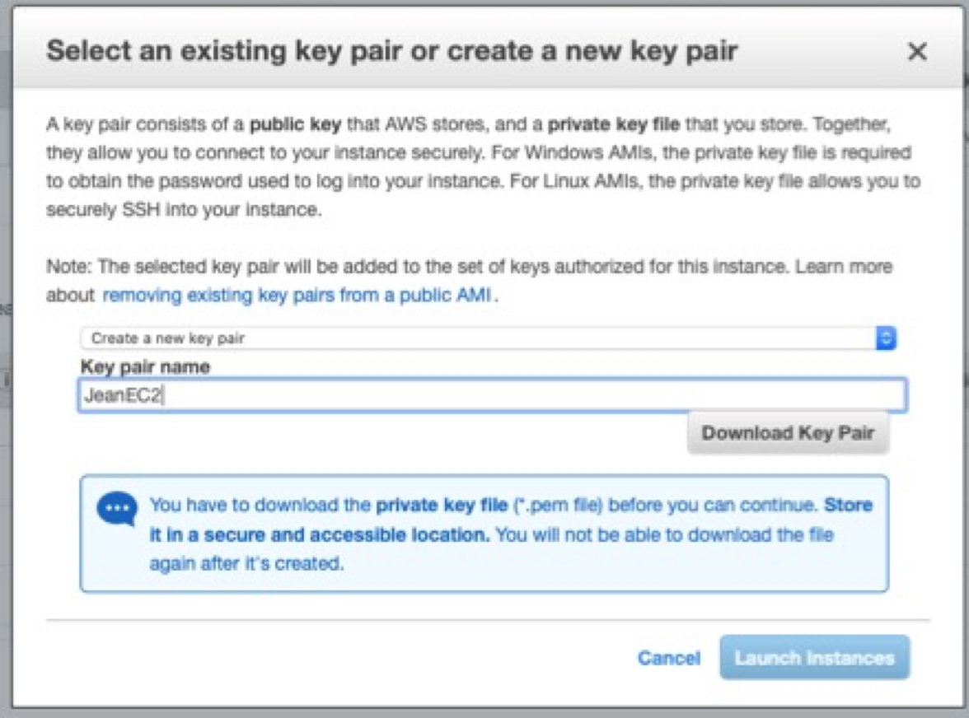

1. Your instance will start and will be ready once the status changes to “Running”:

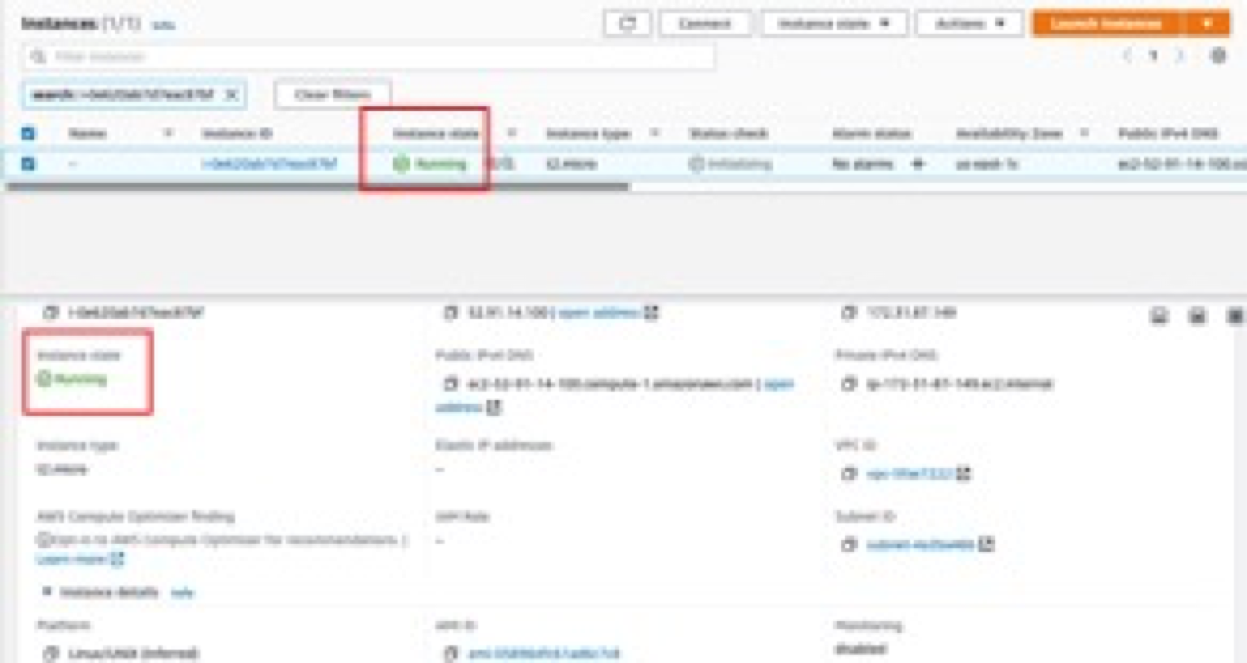

# Set up a SSH connection to the master node

1. You can connect to your instance using SSH to run commands and load your docker container. For this, you will need your **keypair file** and the appropriate permissions set to it so that only you can read the keypair file, e.g.: chmod 400 keypairname.pem. If you do not set these permissions, you will get an Unprotected Private Key File error when connecting to your EC2/EMR instance (Refer to the Appendix).
2. Login to your **public IPv4 DNS address** as **ec2-user** with your **keypair** file, e.g:

ssh -i mykeypair.pem [ec2-user@ec2-52-91-14-100.compute-1.amazonaws.com](mailto:ec2-user@ec2-52-91-14-100.compute-1.amazonaws.com)

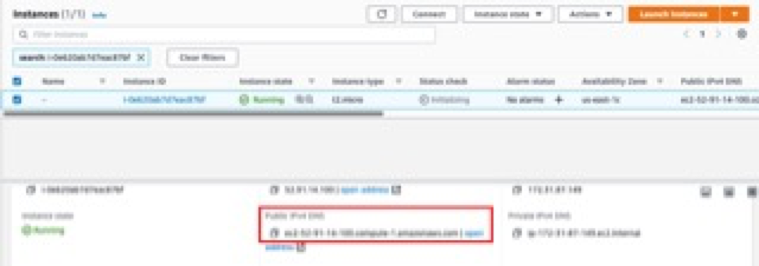

1. Type **yes** to respond to the prompt on the ECDSA key fingerprint, and you’re in!

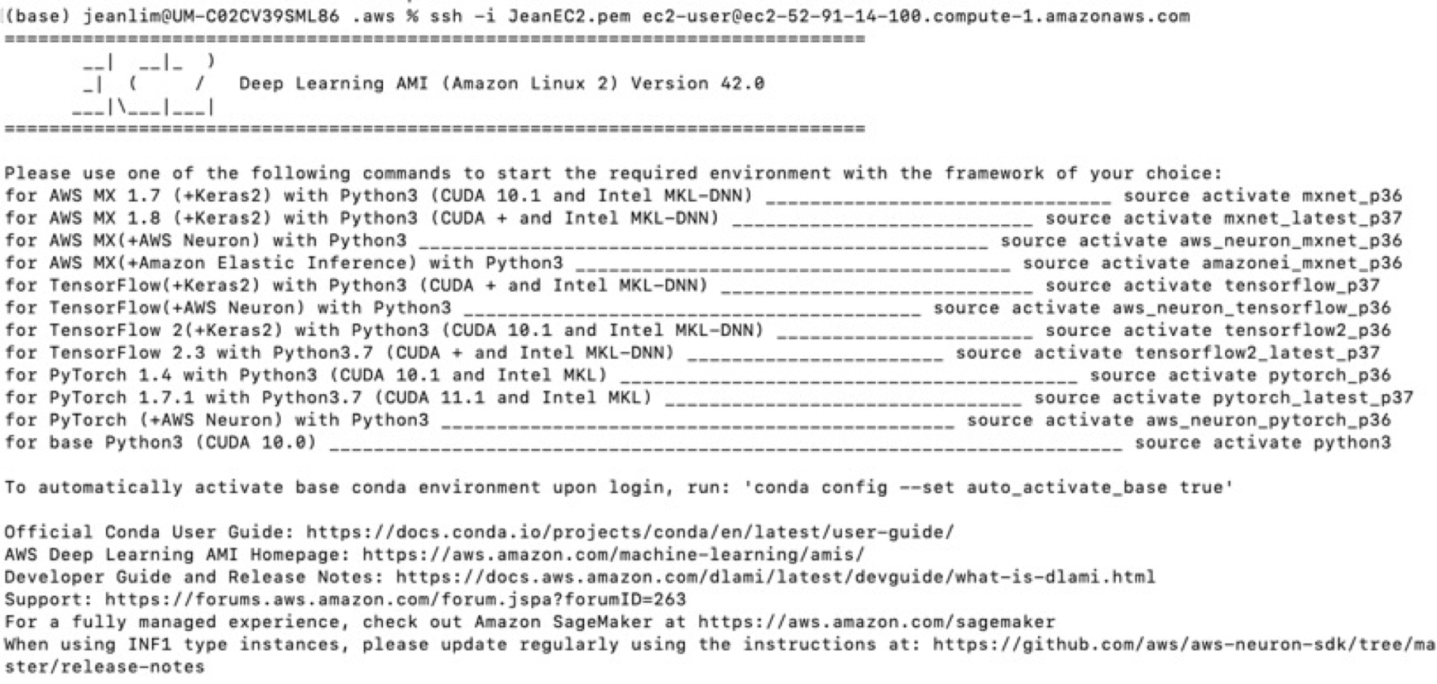

1. Since Docker is already pre-installed, you can just run your Docker commands, e.g.

docker pull aomlomics/tourmaline

docker run -v $HOME:/data/ -it aomlomics/tourmaline

1. Make sure your data is backed up – read on to find out more:

# Creating a bucket for data upload/storage

Full tutorial: <https://docs.aws.amazon.com/AmazonS3/latest/userguide/create-bucket-overview.html>

To upload your data to Amazon S3, you must first create an Amazon S3 bucket in one of the AWS Regions. The AWS account that creates the bucket owns it. You can upload any number of objects to the bucket.

1. Sign in to the AWS Management Console: <https://141650580409.signin.aws.amazon.com/console>
2. Navigate to the S3 console: <https://console.aws.amazon.com/s3/> or click below:

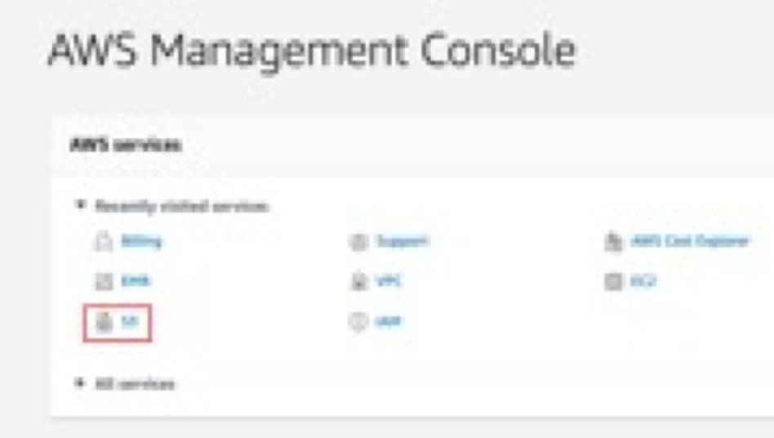

1. Click “Create bucket”:

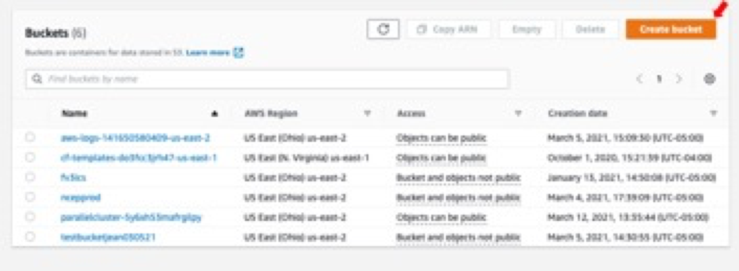

1. **Name** your bucket. After you create a bucket, you cannot change its name or region.

* Bucket names must be between 3 and 63 characters long.
* Bucket names can consist only of lowercase letters, numbers, dots (.), and hyphens (-). However, Amazon recommends that dots should be avoided.
* Bucket names must begin and end with a letter or number.
* More rules at: <https://docs.aws.amazon.com/AmazonS3/latest/userguide/bucketnamingrules.html>

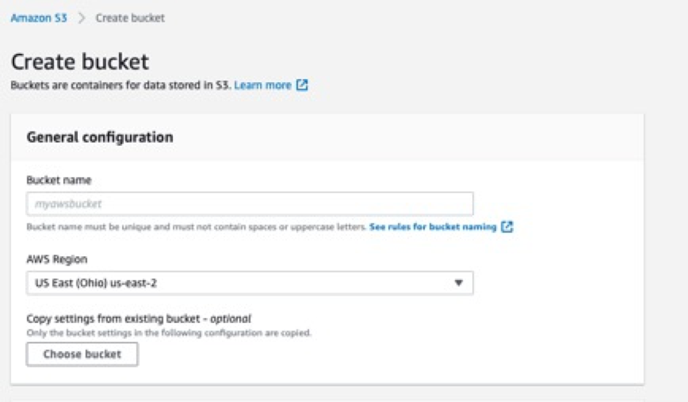

1. In **Region,** choose an AWS region close to you to minimize latency and costs and address regulatory requirements. Objects stored in a Region never leave that Region unless you explicitly transfer them to another Region.
2. In Bucket settings for Block Public Access, choose the **Block Public Access** settings that you want to apply to the bucket. We recommend that you keep all settings enabled unless you know that you need to turn off one or more of them for your use case, such as to host a public website. For more information, see <https://docs.aws.amazon.com/AmazonS3/latest/userguide/access-control-block-public-access.html>

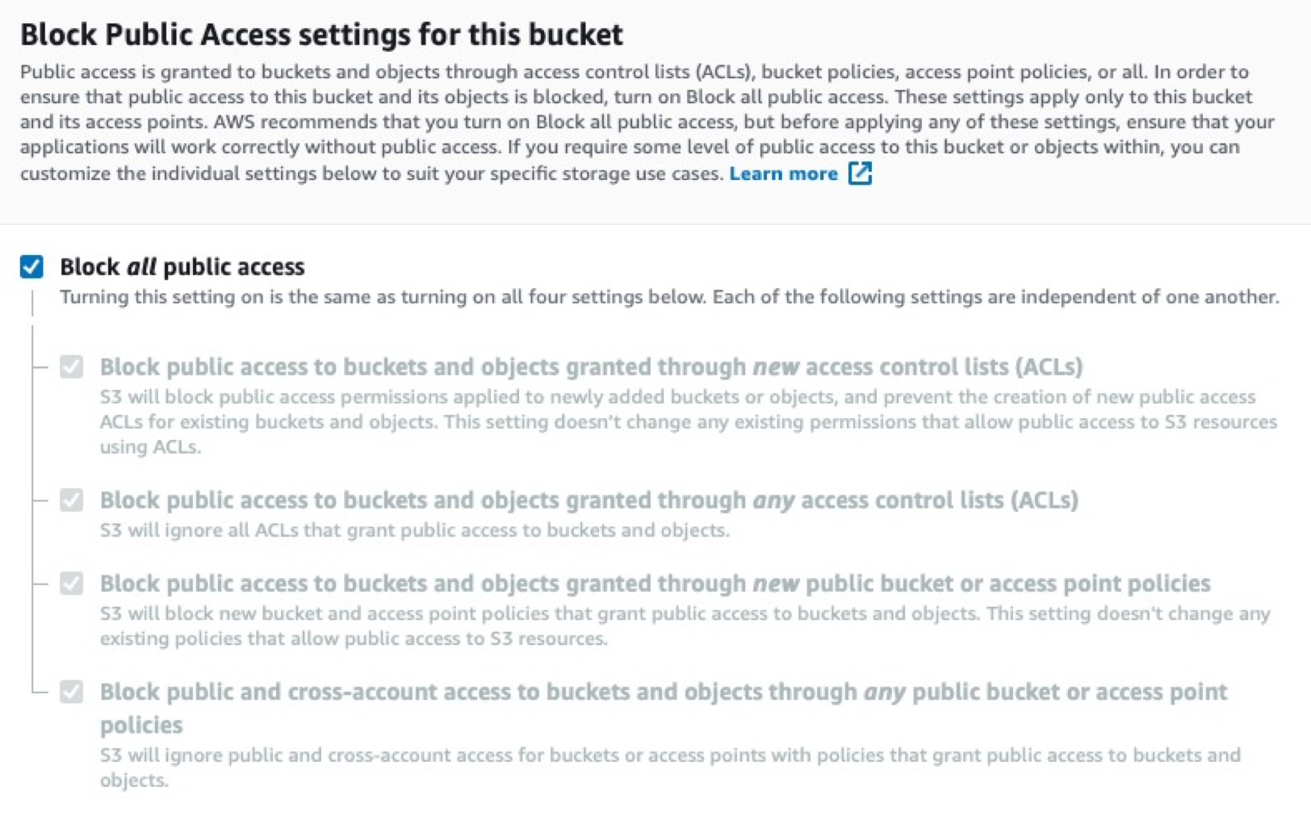

1. [Optional but highly recommended] Enable bucket versioning (<https://docs.aws.amazon.com/AmazonS3/latest/userguide/Versioning.html>)

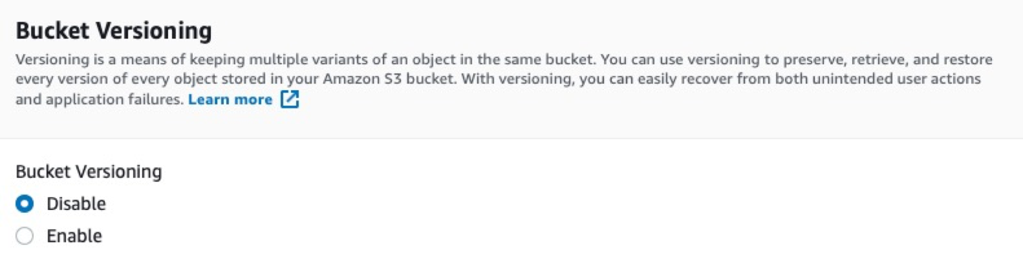

1. Click **Create Bucket**

# AWS command line interface (CLI)

To transfer data between your S3 bucket and Amazon EMR, you will need to use the **AWS command line interface (CLI)** pre-installed on the instance.

AWS CLI is a unified tool to manage your AWS services. You can also download AWS CLI (<https://aws.amazon.com/cli/>) on your local computer. So, instead of clicking through the web console, you can perform all actions in this tutorial using the AWS command line interface (CLI). With just one tool to download and configure, you can control multiple AWS services from the command line and automate them through scripts.

# aws configure

Full tutorial: <https://docs.aws.amazon.com/cli/latest/userguide/cli-configure-quickstart.html>

When you use AWS CLI for the first time, you will need to set it up by typing aws configure. When you enter this command, the AWS CLI prompts you for four pieces of information:

**#1 and #2: Access key ID and secret access key**

If you are a root user, you can create access keys for yourself using the instructions in the tutorial above. Note that you can only download the key pair **once**, so keep the information in a secure place.

**#3: AWS Region**

You can get this information from the master public DNS, if you already have an instance running. In the example below, the region is **us-east-2**

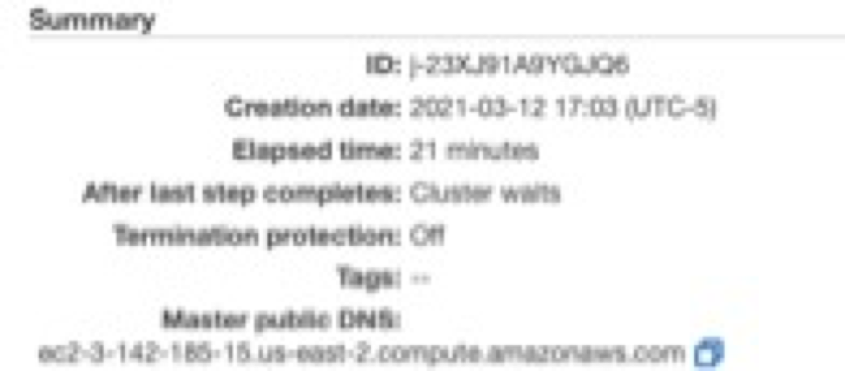

**#4: Output format**

The Default output format specifies how the results are formatted. The value can be any of the values in the following list. If you don't specify an output format, json is used as the default.

* **json** – The output is formatted as a JSON string.
* **yaml** – The output is formatted as a YAML string. (Available in the AWS CLI version 2 only.)
* **yaml-stream** – The output is streamed and formatted as a YAML string. Streaming allows for faster handling of large data types. (Available in the AWS CLI version 2 only.)
* **text** – The output is formatted as multiple lines of tab-separated string values. This can be useful to pass the output to a text processor, like grep, sed, or awk.
* **table** – The output is formatted as a table using the characters +|- to form the cell borders. It typically presents the information in a "human-friendly" format that is much easier to read than the others, but not as programmatically useful.

# Access files in S3 bucket from an AWS instance

AWS CLI is useful for backing up data from your AWS instance to a S3 bucket or to transfer files from S3 bucket to your instance. Here is a list of useful commands you can run after you have set up a SSH connection to your master node:

* List all buckets available: aws s3 ls
* List contents of a bucket: aws s3 ls testbucketjean030521
* Copy files from bucket to local machine: aws s3 cp s3://testbucketjean030521/panda.ipynb var/lib/jupyter/home/jovyan/
* Copy all files and folders recursively: aws s3 cp . s3:// testbucketjean030521 --recursive
* Sync a local directory with a bucket. Note that this Sync does not copy the existing files and folders from the local machine to the bucket. It just copies the files which have been newly created or modified: aws s3 sync . s3:// testbucketjean030521

# Clean up Amazon EC2 Resources

Once you are done with your work, remember to terminate the cluster and empty/delete your designated Amazon S3 bucket to avoid additional charges.

# Terminate the EC2 instance

1. If you had enabled **Termination Protection**, you will need to disable it before you can terminate your instance. On the EC2 console, select your instance, then click on **Actions** -> **Instance settings** -> **Change termination protection**

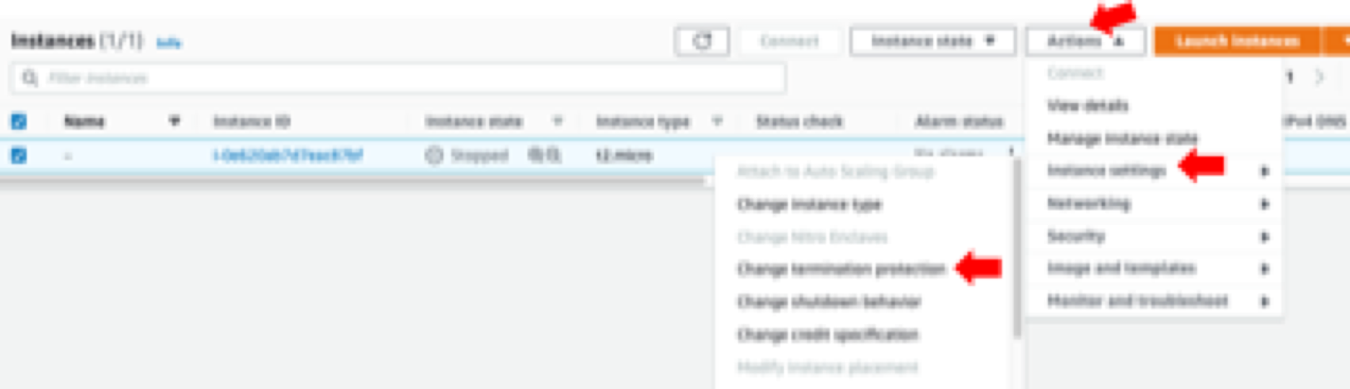

1. Uncheck the “enable” checkbox then click Save

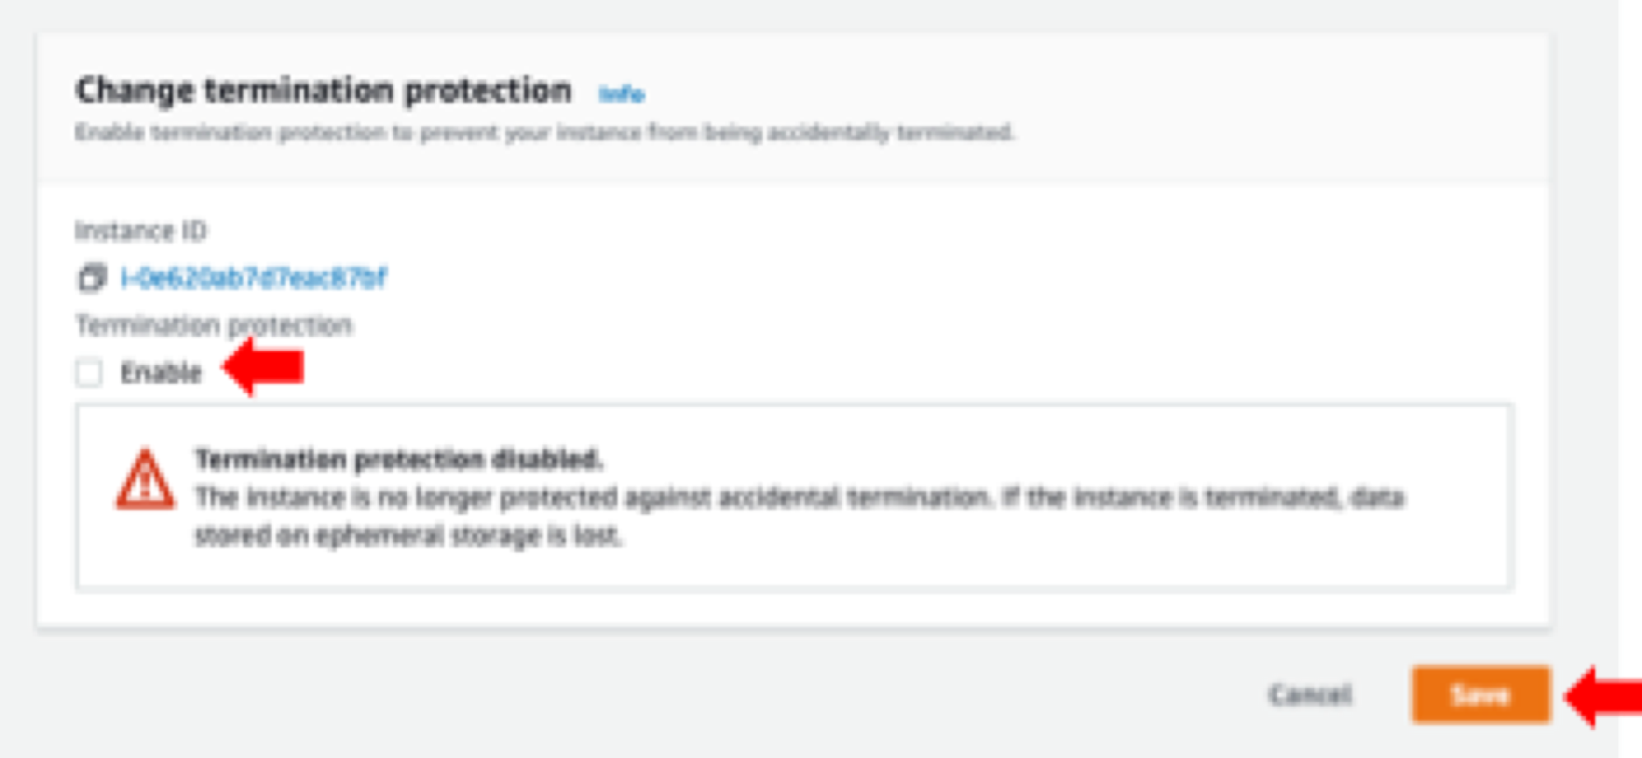

1. Now you can terminate your instance by selecting it, then clicking on **Instance state** -> **Terminate Instance**.You can also stop, reboot, or hibernate your instance here.

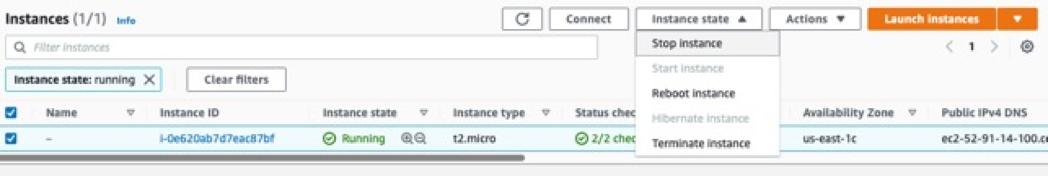

1. This will bring up the Terminate cluster prompt. Click on “Change” to turn off termination protection:

# Empty/delete your S3 bucket

Full instructions here: <https://docs.aws.amazon.com/AmazonS3/latest/userguide/creating-buckets-s3.html>

1. Sign in to the AWS Management Console and open the Amazon S3 console at <https://console.aws.amazon.com/s3/>.
2. In the Buckets list, select the option next to the name of the bucket that you want to delete, and then choose **Empty** or **Delete** at the top of the page.

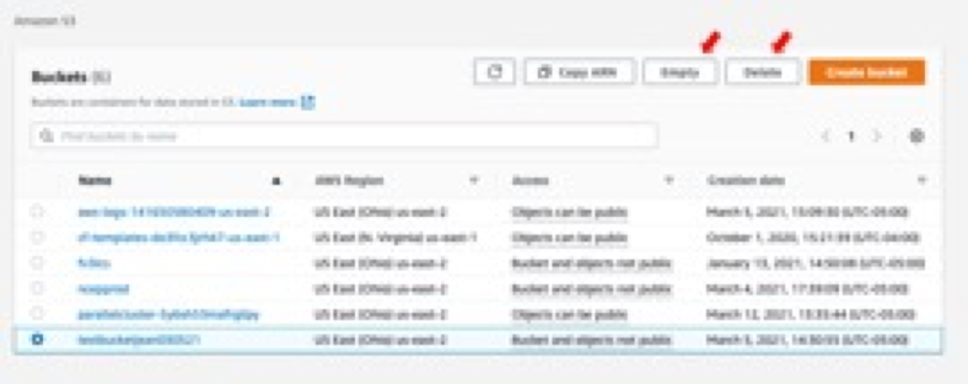

1. If you are deleting your bucket, confirm that you want to delete the bucket by entering the bucket name into the text field, and then choose Delete bucket.

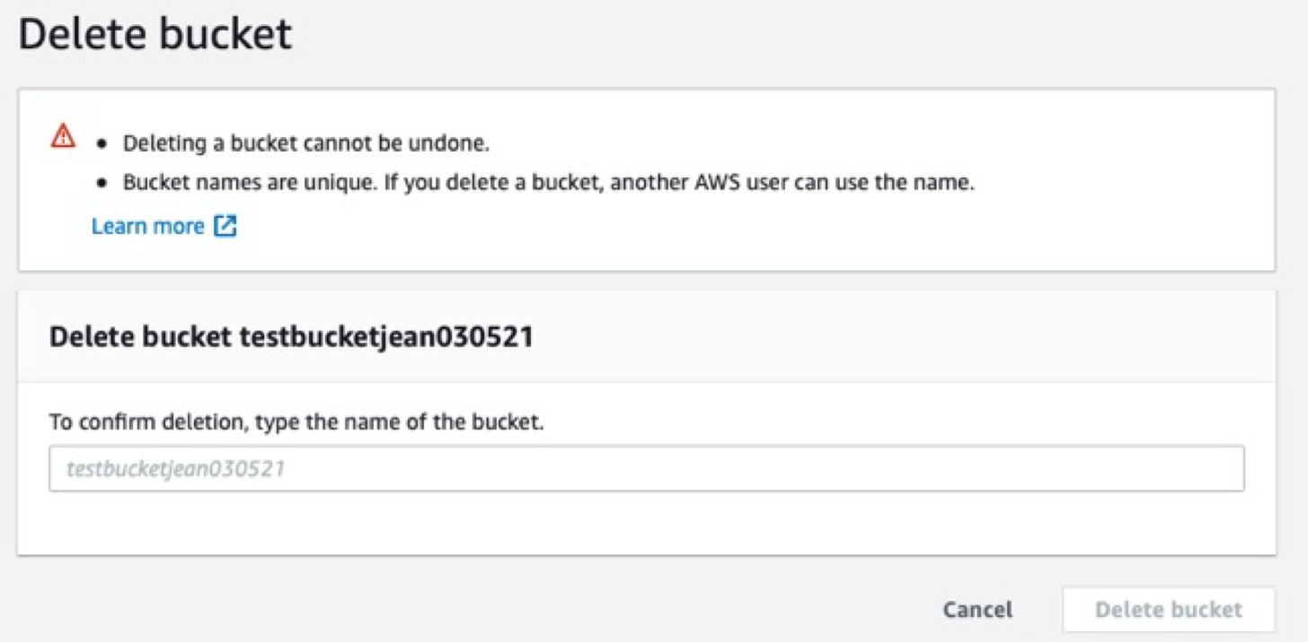

**Note:** When you delete a bucket that has S3 Bucket Versioning enabled, all versions of all the objects in the bucket are permanently deleted.

# Appendix – Create PEM and PPK format key pairs

Full tutorial: <https://docs.aws.amazon.com/AWSEC2/latest/UserGuide/ec2-key-pairs.html>

A key pair, consisting of a **public** key and a **private** key, is a set of security credentials that you use to prove your identity when connecting to an instance. When your instance boots for the first time, the content of the public key that you specified at launch is placed on your Linux instance in an entry within ~/.ssh/authorized_keys. When you connect to your instance using SSH, to log in you must specify the private key that corresponds to the public key content. You use the private key, instead of a password, to securely access your instances. If you plan to connect to the instance using SSH, you must specify a key pair.

1. Sign in to the AWS Management Console: <https://141650580409.signin.aws.amazon.com/console>
2. Navigate to the EC2 console: <https://console.aws.amazon.com/ec2/> or click below:



1. In the navigation pane, under Network & Security, choose Key Pairs and click “**Create key pair**”:

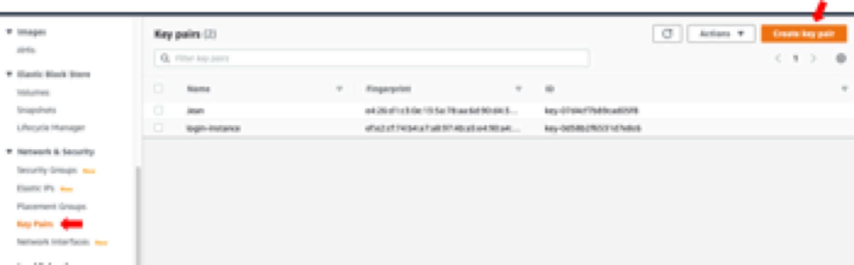

1. For **Name**, enter a descriptive name for the key pair. Amazon EC2 associates the public key with the name that you specify as the key name. A key name can include up to 255 ASCII characters. It can’t include leading or trailing spaces.

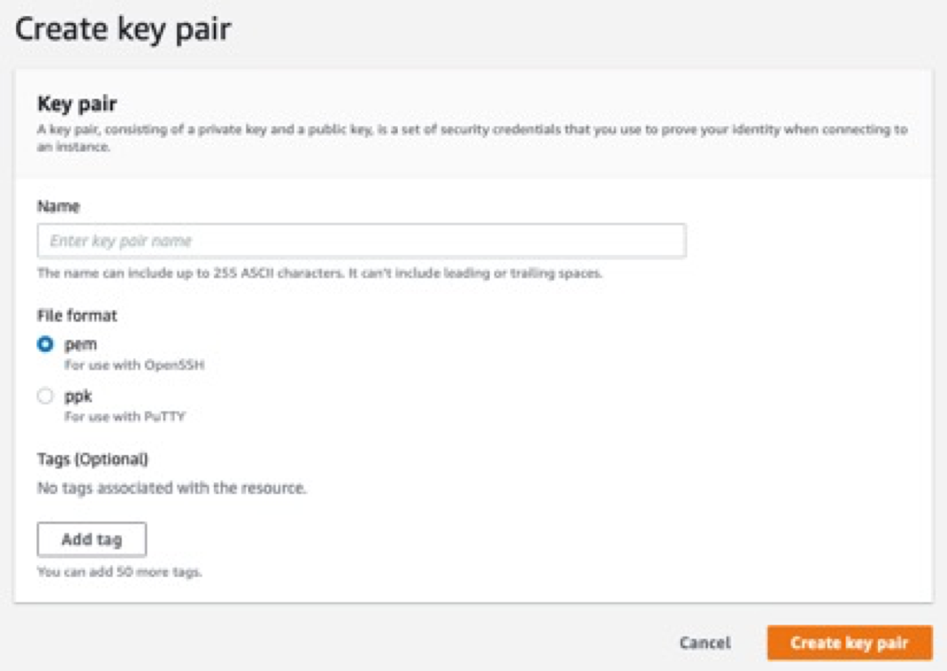

If you are using PuTTY for Windows, Mac, or other OS, choose ppk format. For other SSH clients, pem is probably the safer bet.

1. For **File format**, choose the format in which to save the private key. To save the private key in a format that can be used with OpenSSH, choose pem. To save the private key in a format that can be used with PuTTY, choose ppk.
2. Choose **Create key pair**.
3. The private key file is automatically downloaded by your browser. The base file name is the name you specified as the name of your key pair, and the file name extension is determined by the file format you chose. Save the private key file in a safe place.

Important: **This is the only chance for you to save the private key file**.

1. If you will use an SSH client on a macOS or Linux computer to connect to your Linux instance, use the following command to set the permissions of your private key file so that only you can read it, e.g.: chmod 400 keypairname.pem

If you do not set these permissions, then you will get the following error when connecting to your EC2/EMR instance:

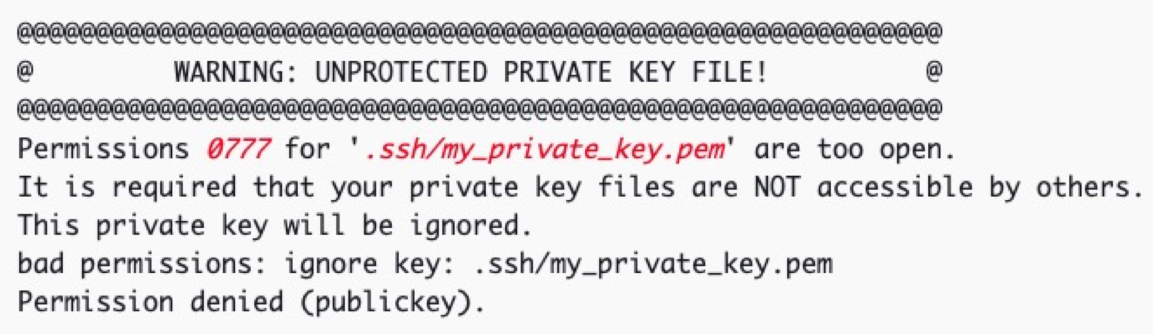

Other connection errors can be troubleshooted here: <https://docs.aws.amazon.com/AWSEC2/latest/UserGuide/TroubleshootingInstancesConnecting.html#troubleshoot-unprotected-key>